**Name**: Karthikeyan K R

**Date**: 05-01-2024

**Topic**: Azure Data Factory and Copy Activity in ADF

**Type**: Daily Assignment

**Azure Data Factory**

Azure Data Factory is a cloud-based data integration service provided by Microsoft Azure. Its primary purpose is to help organizations efficiently collect, process, and move data from various sources to different destinations.

**Copy Activity in Azure Data Factory**

**Step 1**: Creating one blob storage which is my source storage

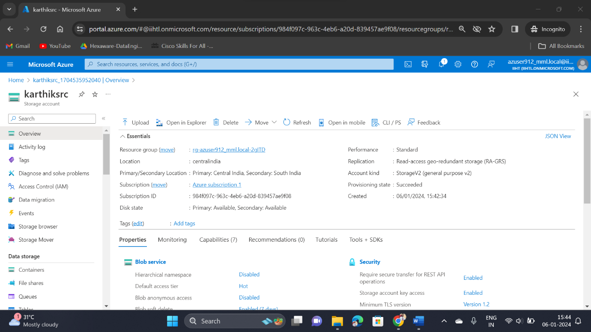

**Step 2**: Then created a new container and upload the files into it

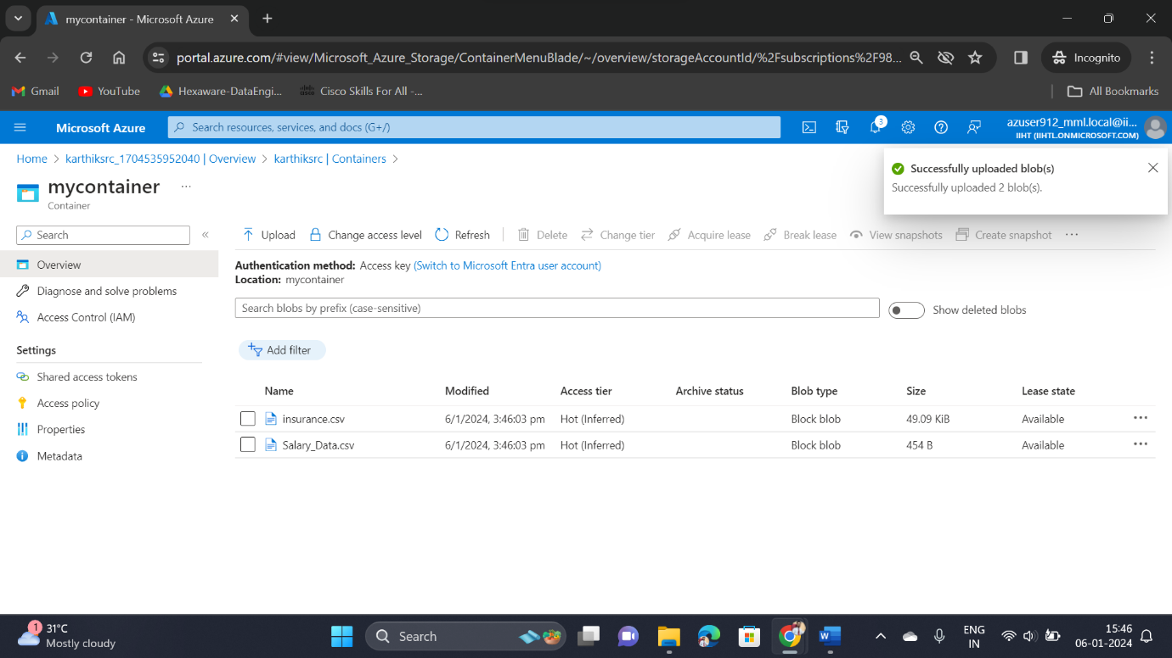

**Step 3**: Then I have created a Azure Data Lake Storage which is my destination location where I needed the files to be copied

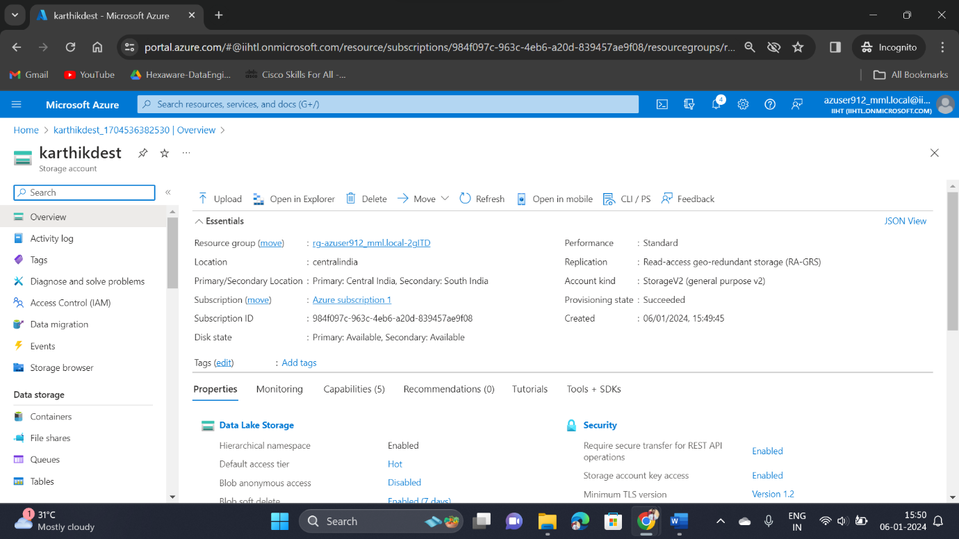

**Step 4**: Creating a Data Factory

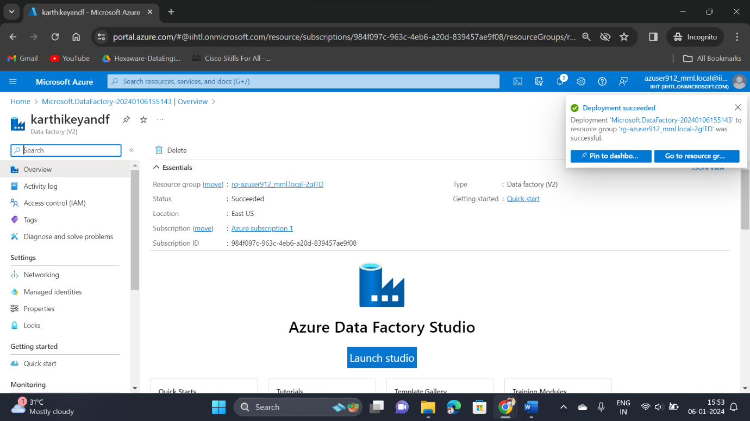

**Step 5**: Select Launch Studio and click ingest option to start the process

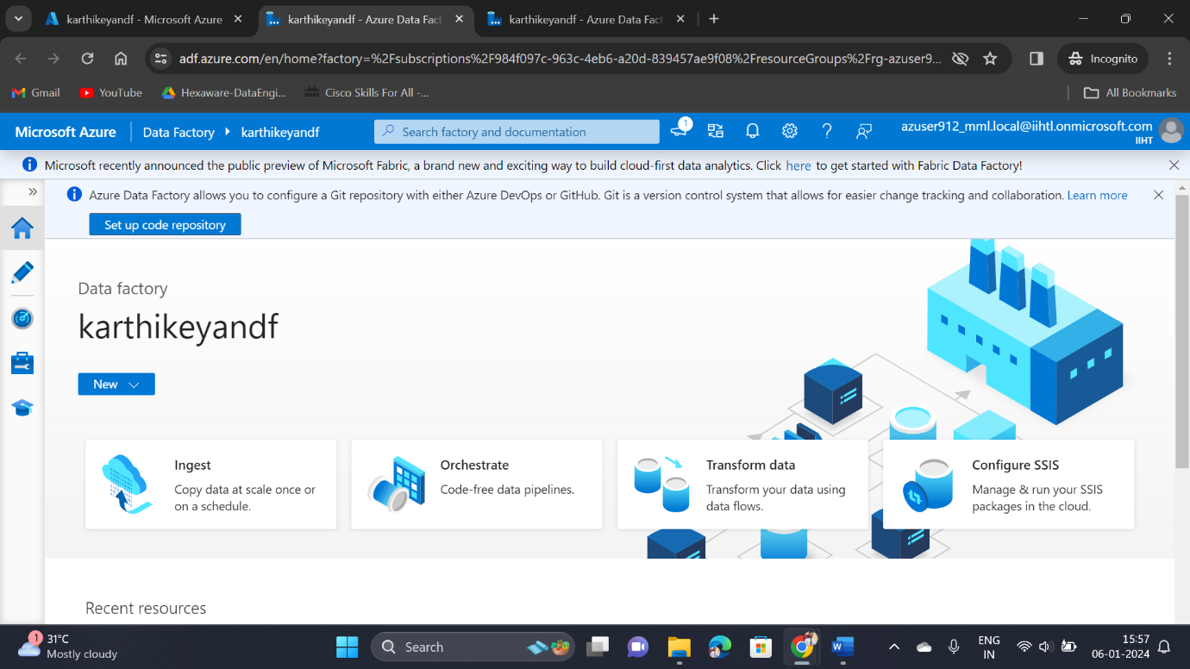

**Step 6**: Then select the task type as Built-in-copy task and task type as Run once now

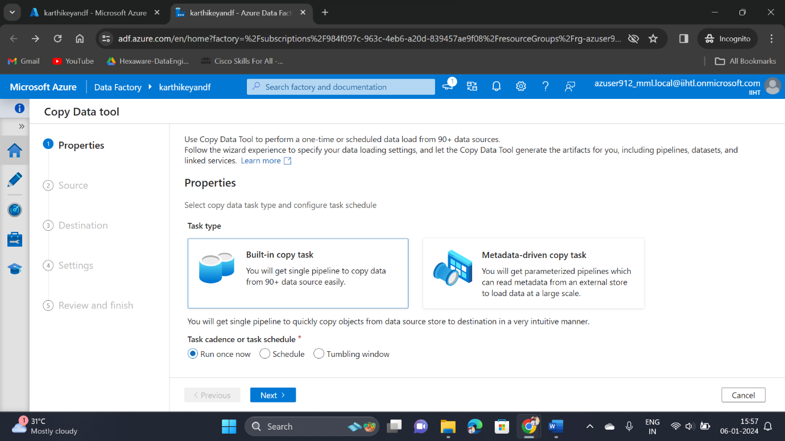

**Step 7**: Now fill the details of your source data location

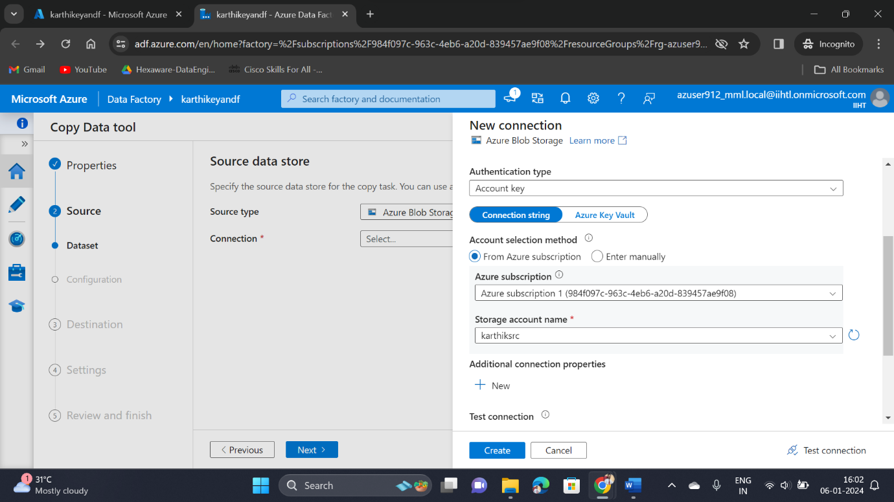

**Step 8**: Once filling the source details and click the test connection, now it will validate and give the connection from source

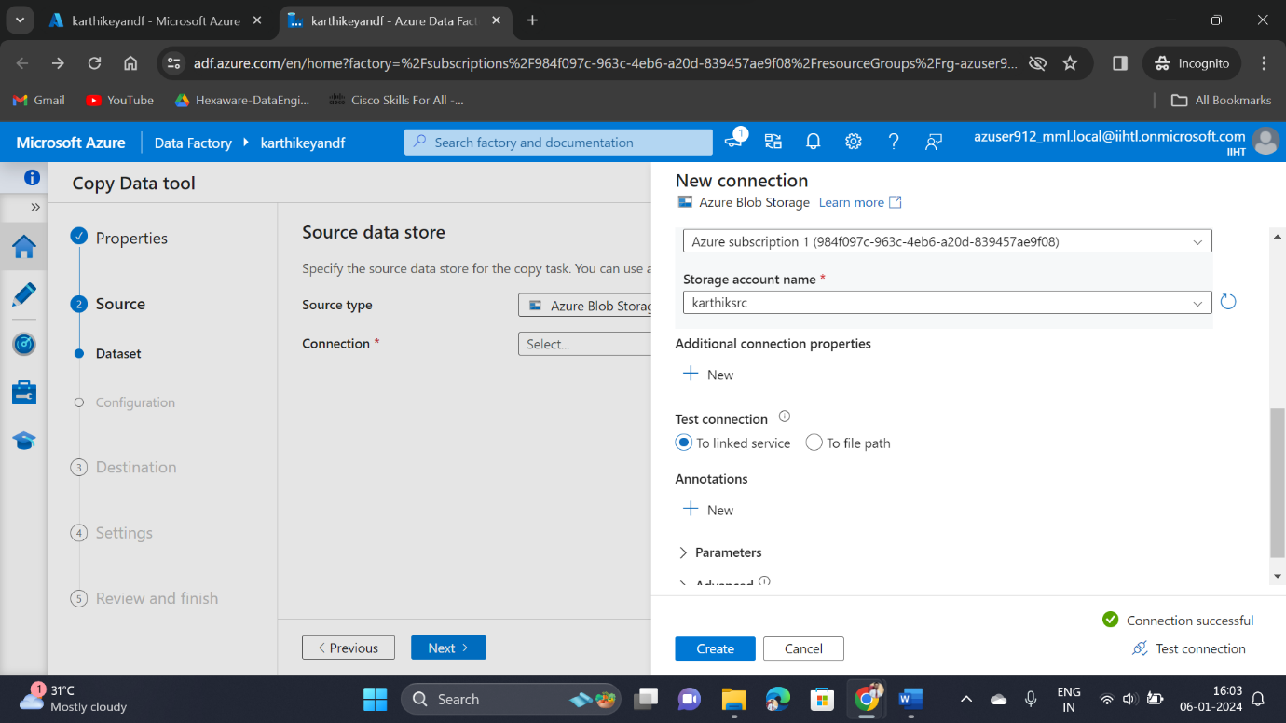

**Step 9**: Then Select the container source address

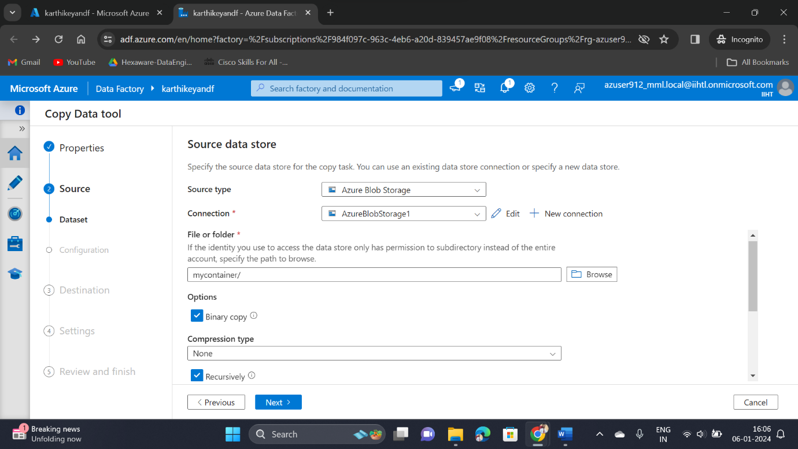

**Step 10**: Then fill the Destination storage address

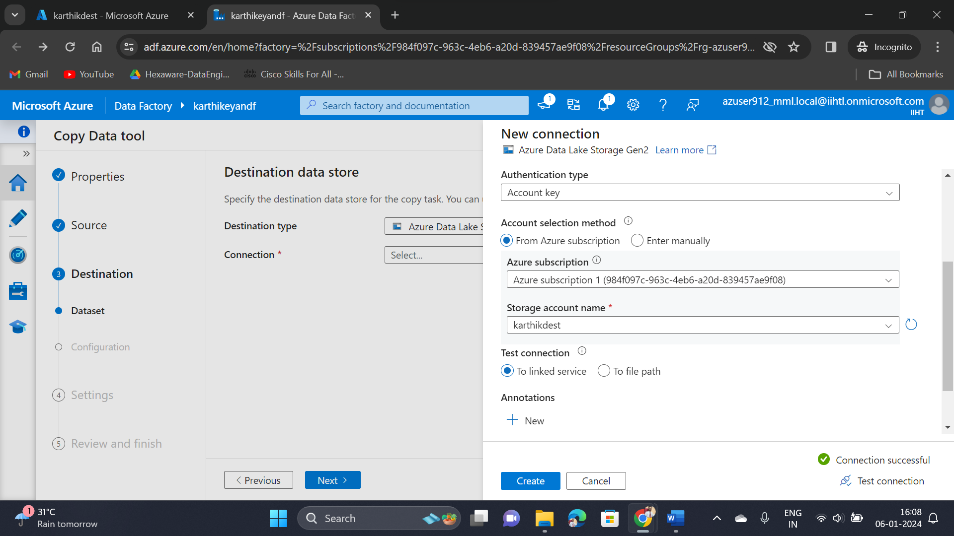

**Step 11**: Enter the Destination Container address where file needs to be moved

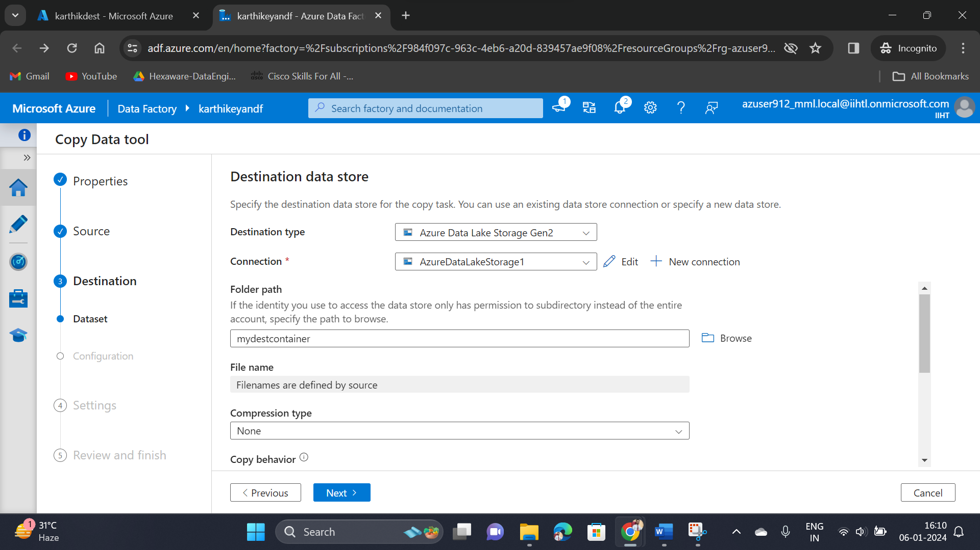

**Step 12**: Give the task and click on next to proceed further

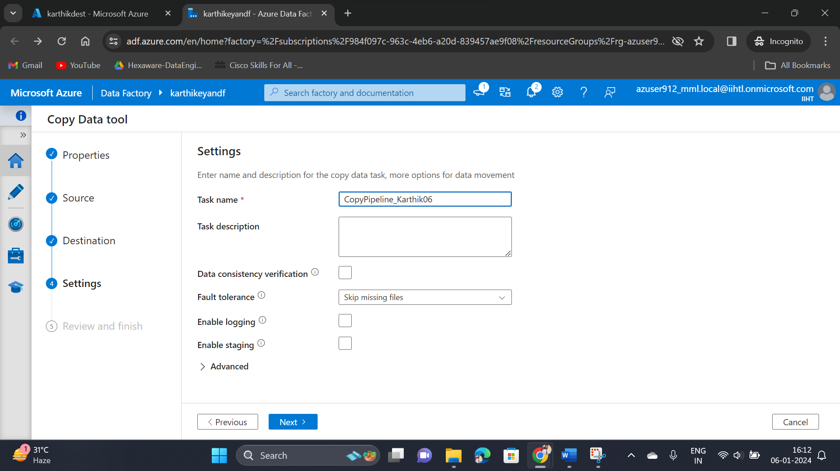

**Step 13**: In Summary we can able to see the source address & destination address and overall summary for the process

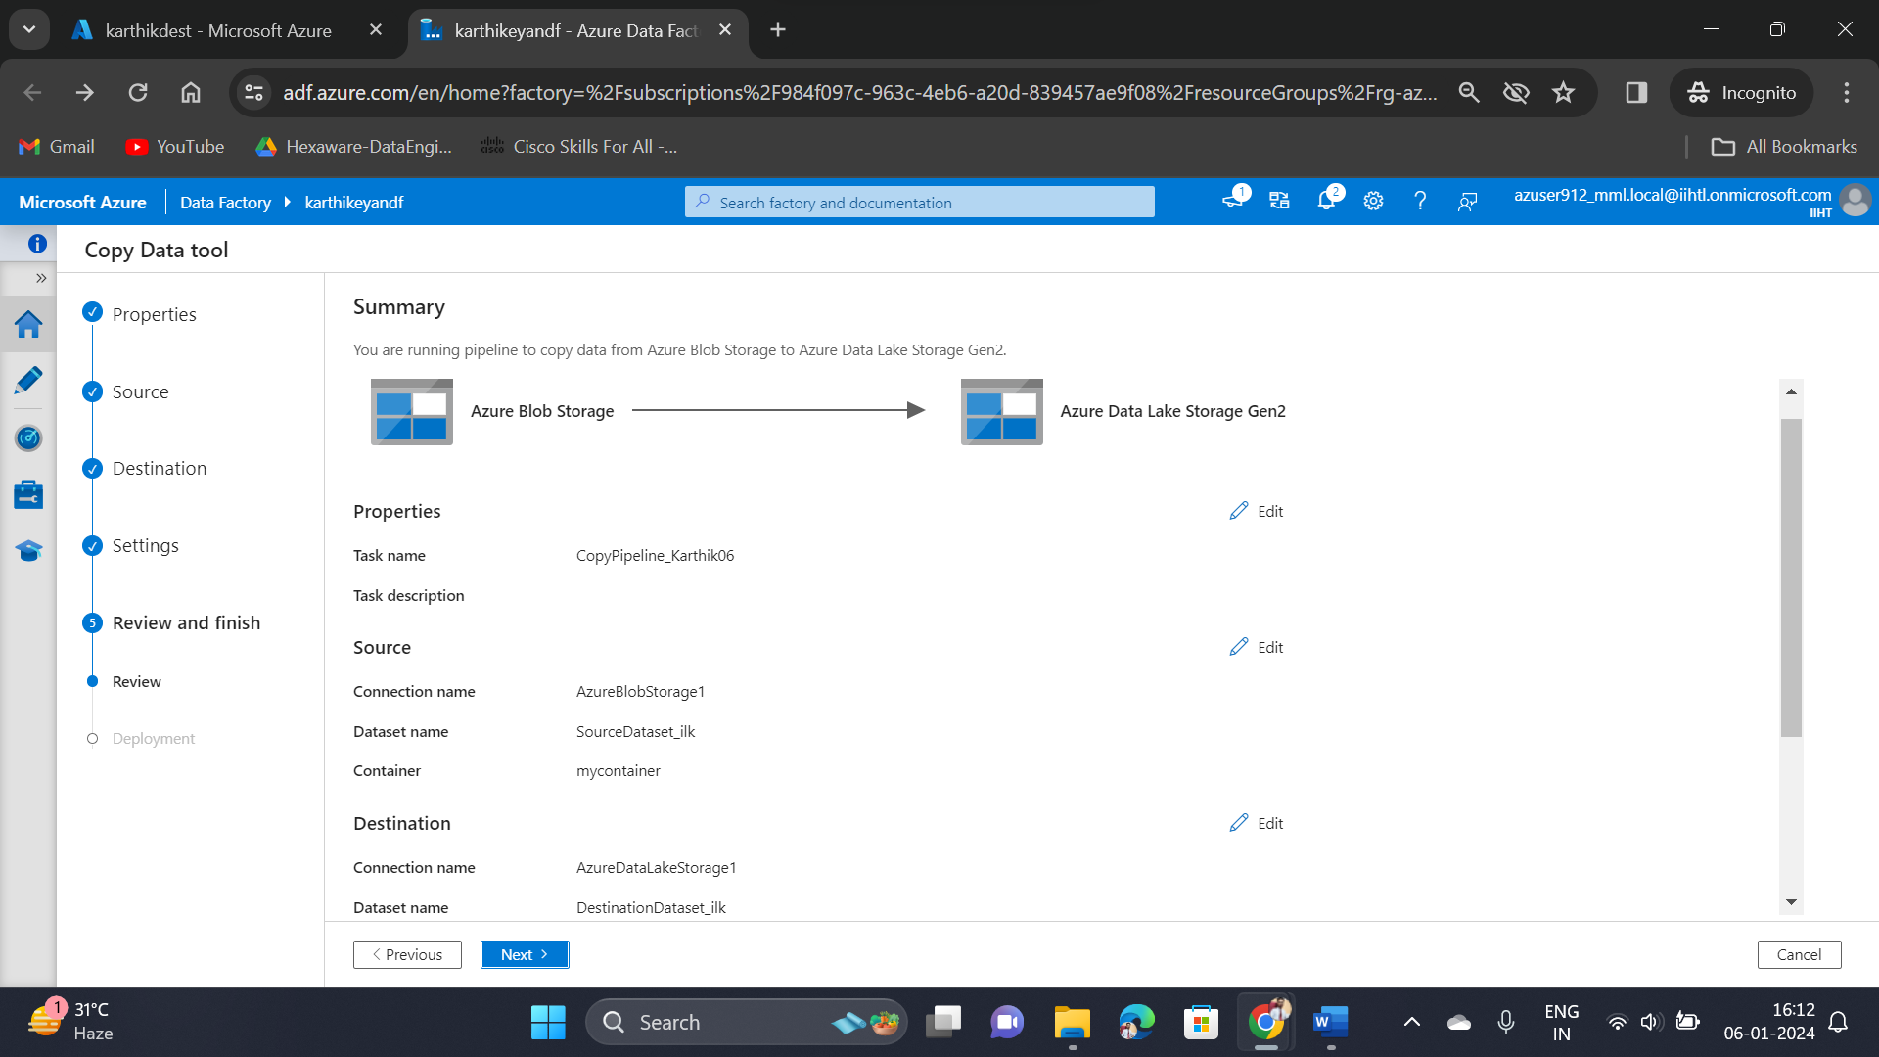

**Step 14**: Now the deployment will take place, once completed we can able to see the copied files

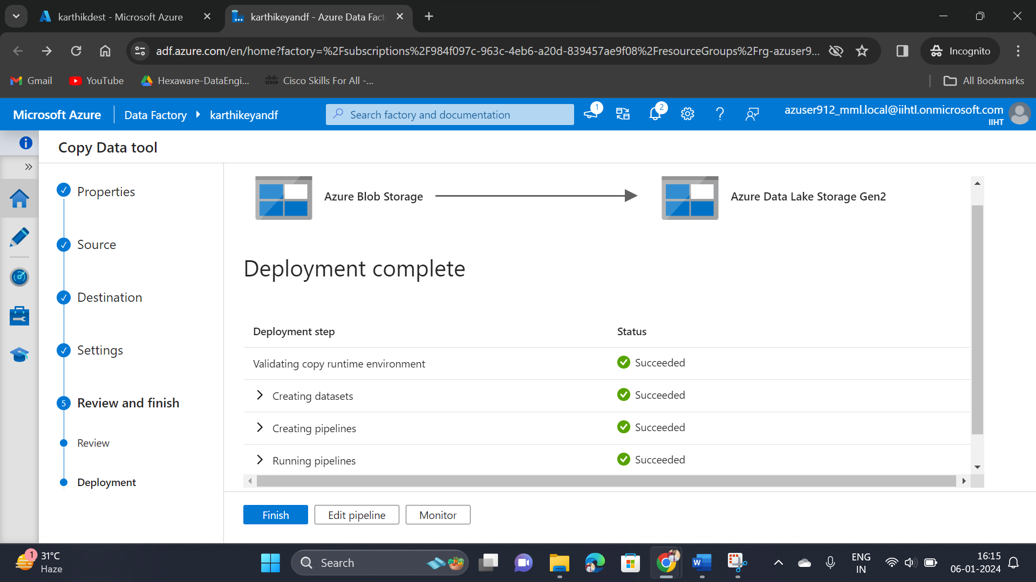

**Step 15**: Go to the Destination container location, there you can able to see the copied files in there

